***Data Science Project Lifecycle***

***Project Progress Report***

**4th February – Initial Research and Planning**

At the start of the project, Kel took the initiative to create a Google Drive folder to ensure a centeralised location for all documents, making collaboration easier for everyone. One of the first documents I created was the interview file, where all team members could contribute their questions before we finalised them for Resole representative.

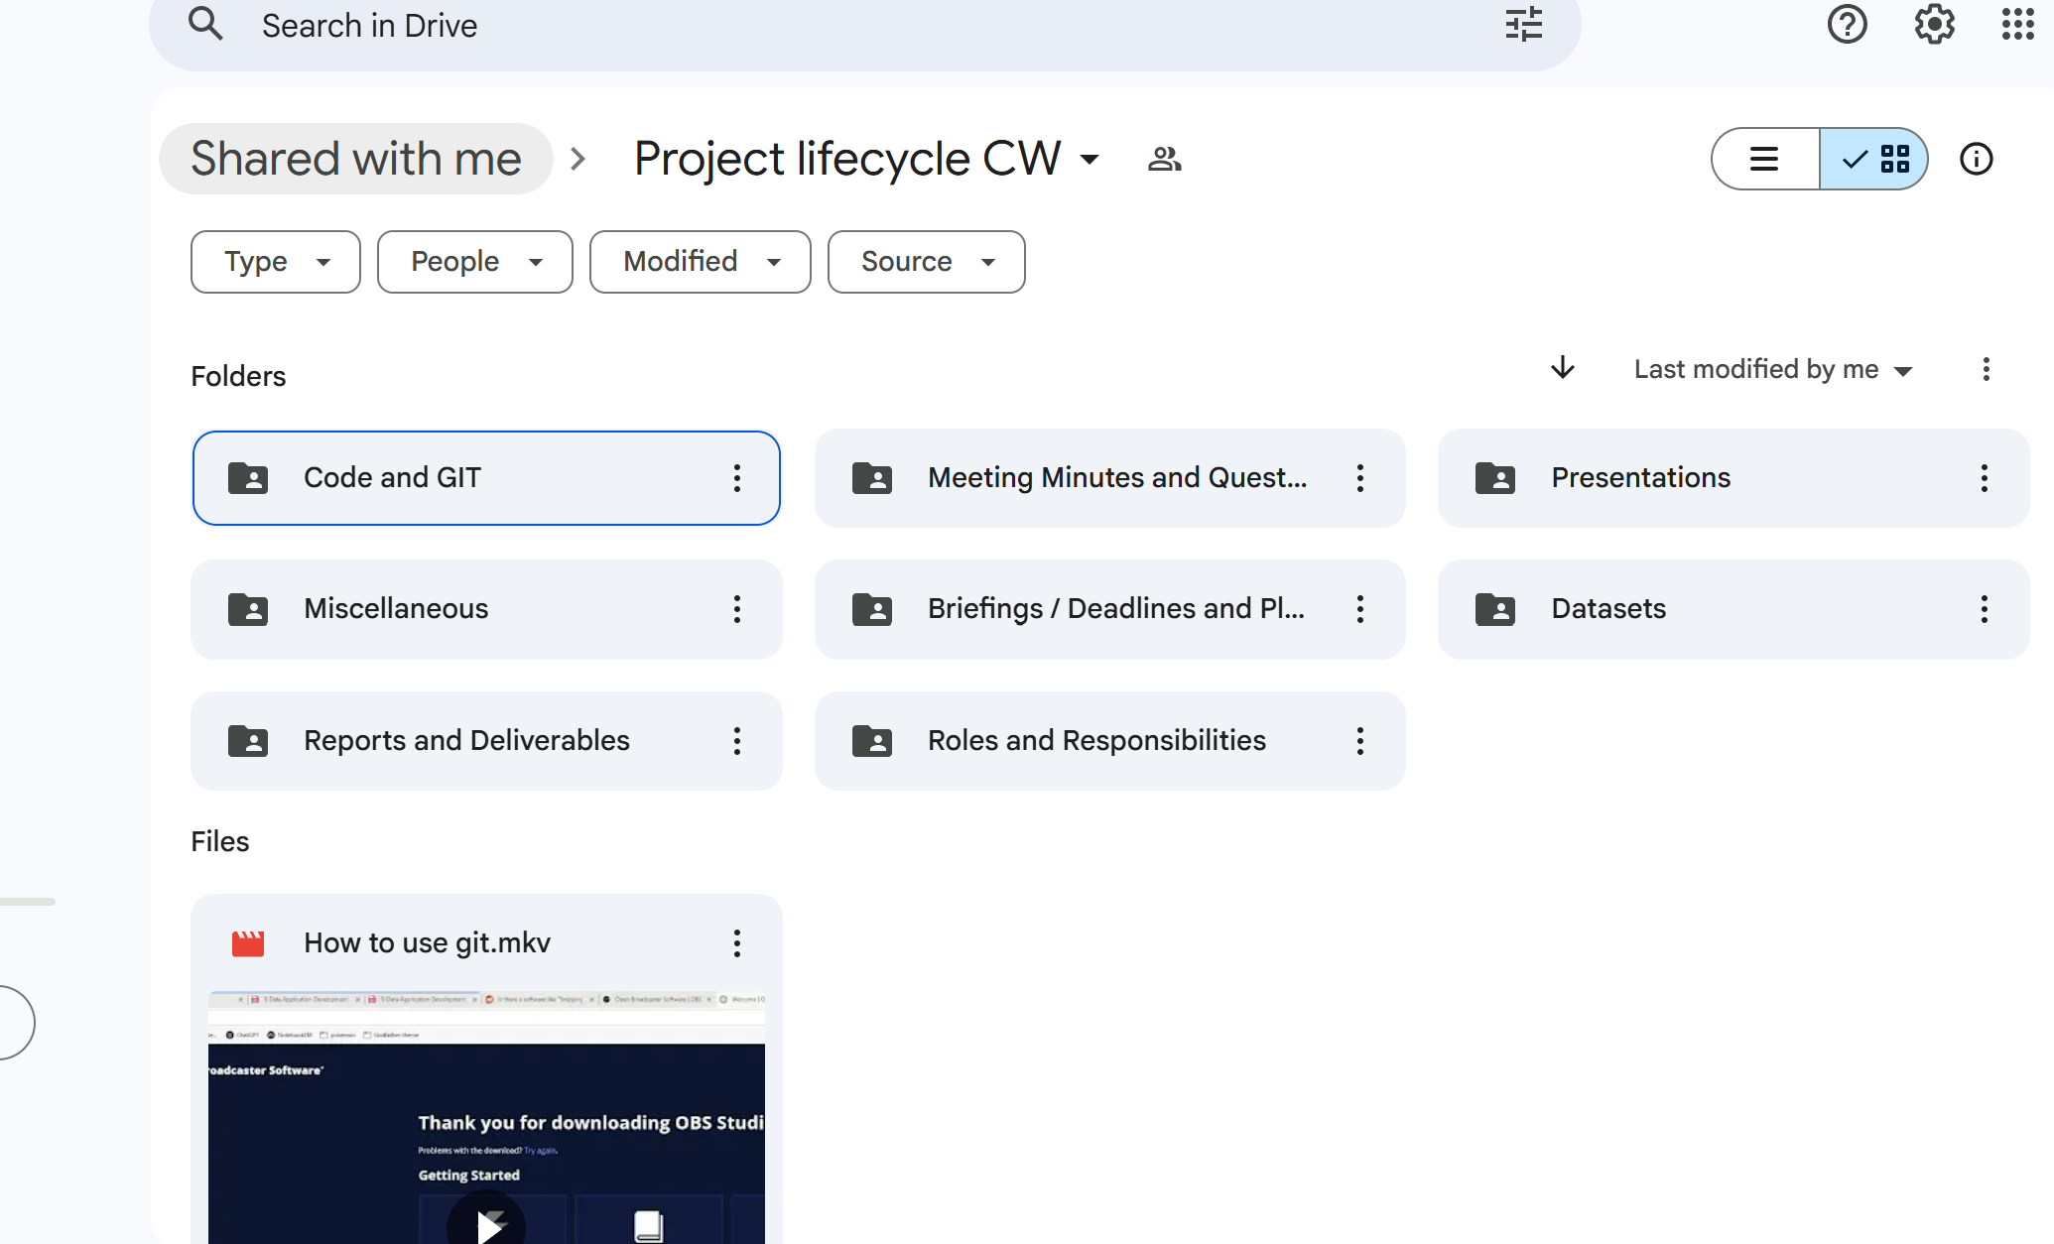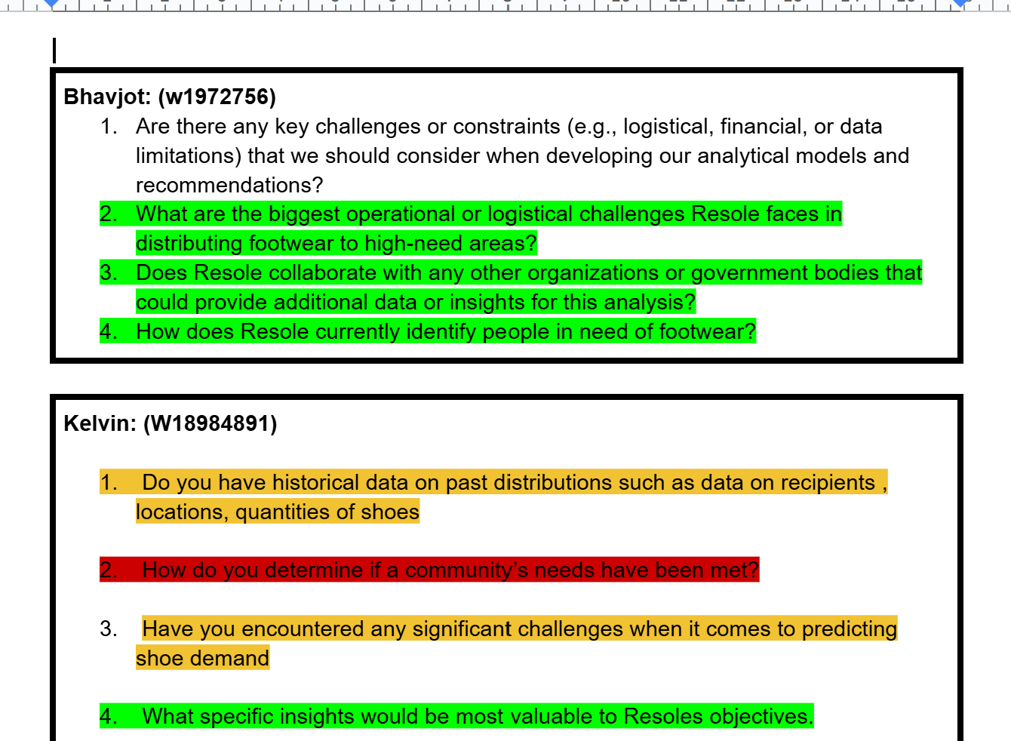

The purpose of highlights is to show the questions that have been selected by each of us, we then have a summarised version at the bottom in which we select the main question that we will be asking the Resole Representative.

Alongside this, I conducted background research on Resole to assist my teammates with their introductions. This research helped me understand Resole’s mission and objectives, which also assisted me in starting the planning phase which would be a key component of our project.

**Next Steps:**

To finalise the list of interview questions, I planned to collect suggestions from the team and organise them into an overview.

**6th February – Meeting Minutes & Structuring Questions**

By this date, I had successfully completed my introduction and established a meeting minted plan to track team contributions.

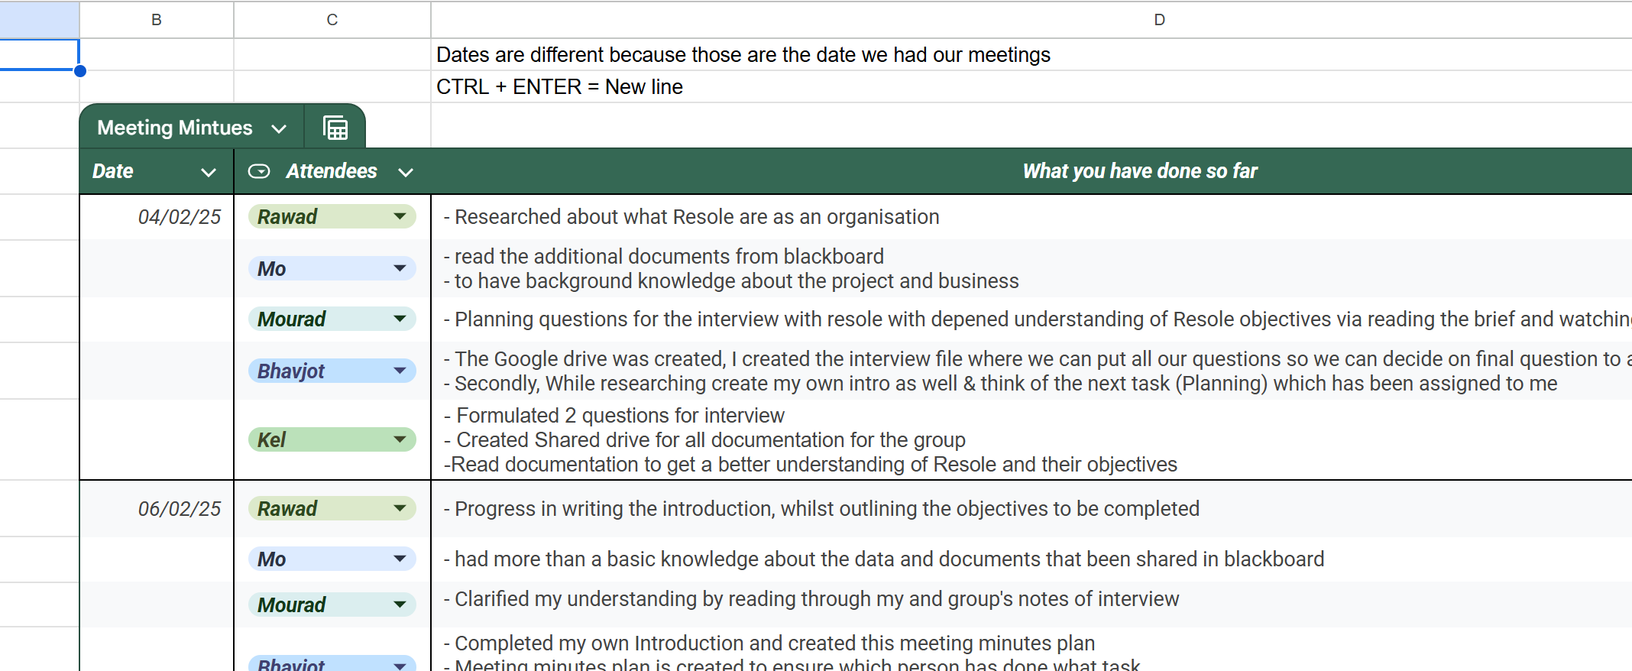

To streamline the interview task, I created a table structure where all question were categorised, and a notes section was included to record responses during the interview. This structed format made it easier to document insights and maintain clarity. Additionally, the meeting minutes plan was designed to ensure that we had a clear record of who was responsible for what tasks.

**Next Steps:**

With the foundational documents in place, I was ready to begin the planning phase/task as outlined in the mark scheme.

**14th February – Progress Check & Gantt Chart Development**

By mid-February, I conducted a progress check on all group members to ensure alignment with the project objectives. As part of my contributions, I created an initial draft report to document our findings and progress.

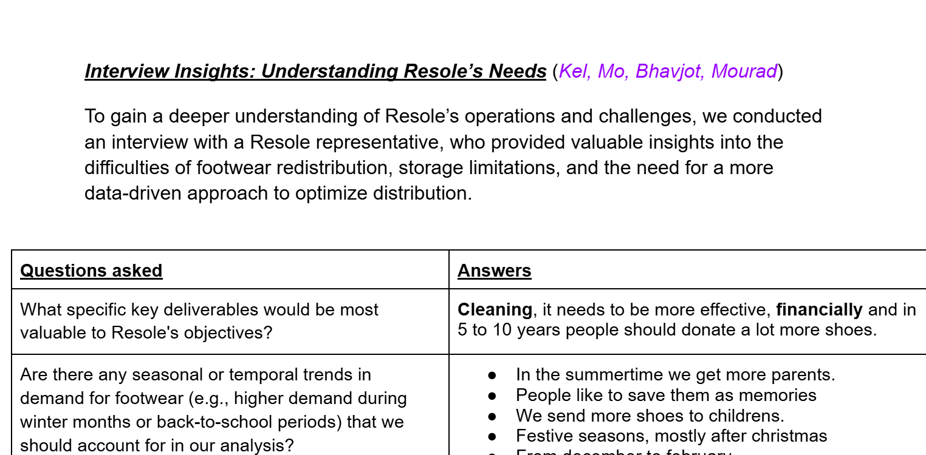

In addition, I regularly updated the meeting minutes and actively planned upcoming meetings to keep the project on track. One of my key deliverables was the Gantt Chart, which mapped out our project timeline and task dependencies. The purpose of using a Gantt Chart is for a visual representation of deadlines and ensuring we had a structed plan.

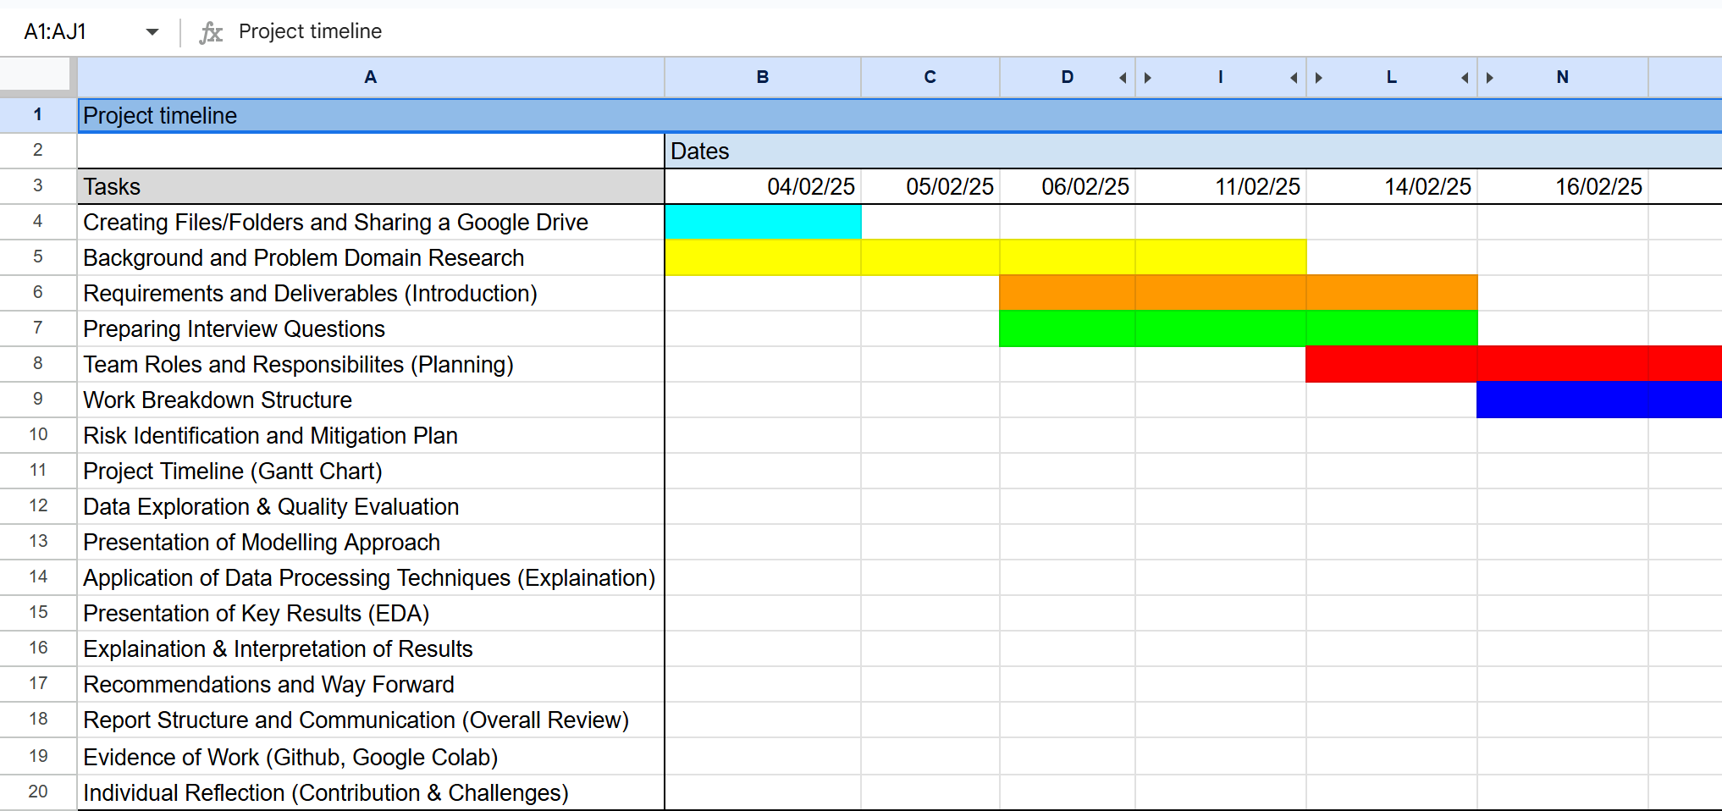

**Next Steps:**

I planned to support Rawad with his final introduction and ensure that we received feedback from the lecturer before submitting the initial draft report.

**17th February – Lecturer Feedback & Document Revisions**

We received valuable feedback from the lecturer regarding our project’s progress. Based on these suggestions, Bhavjot (Me) & Rawad conducted a meeting to implement necessary changes in both the initial draft report and Gantt chart.

**Next Steps:**

To further improve our work, we needed to properly assign tasks, conduct a risk assessment, and contingency plan to align with the marking scheme.

**18th February – Updating Documents & Preparing for Data Phase**

Following the feedback session, I worked on creating a revised initial draft report and made adjustments to the Gantt Chart.

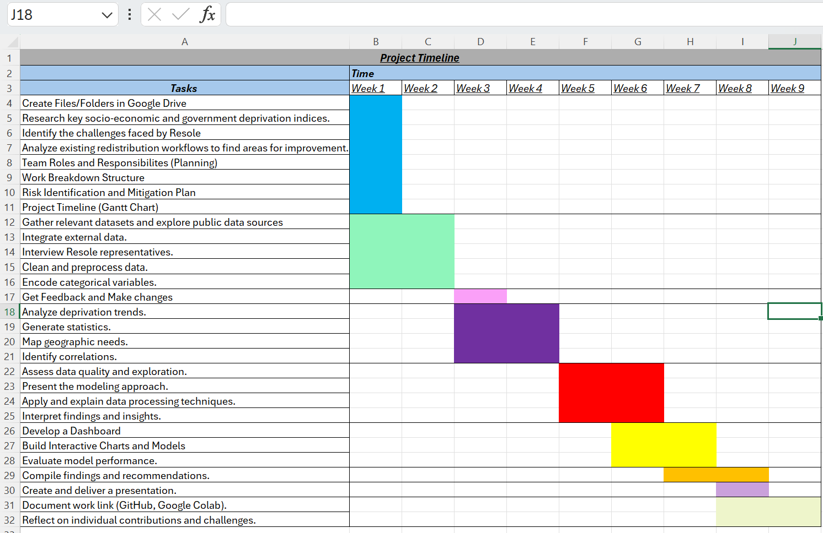

**Next Steps:**

For the next meeting, a review will be conducted across the team. Additionally, once the datasets were finalised, I planned to assist Mourad with data cleaning and preprocessing.

**20th February – Planning Phase Completion**

At this stage, I successfully completed the planning phase, which included **Work Breakdown Structure (WBS), Project Deliverables, Risk & Mitigation Plan, Roles & Responsibilities Allocation, Mark Scheme Checklist.**

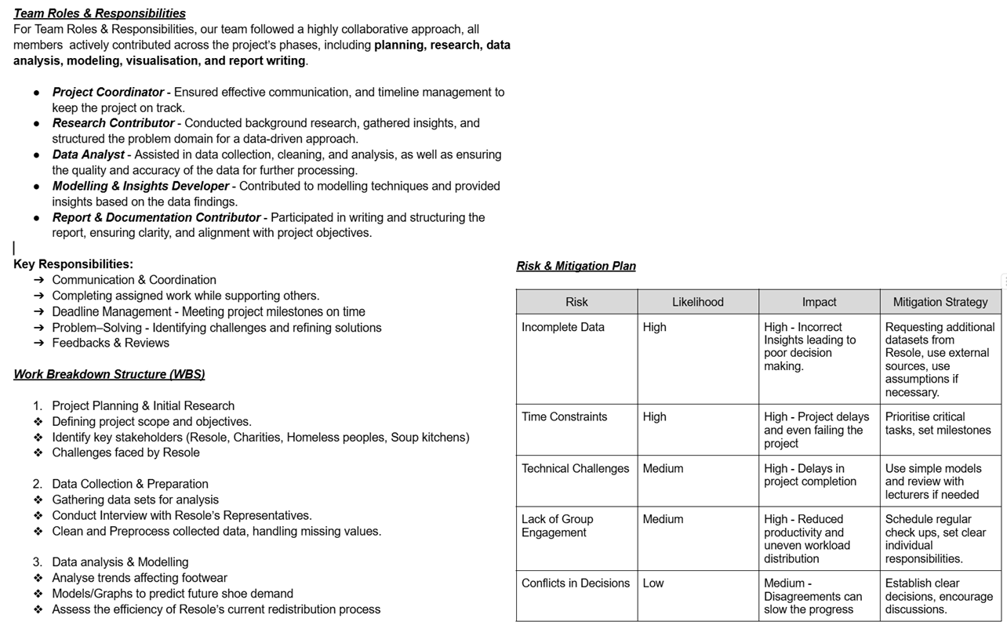

**Next Steps:**

The focus now shifted deciding which datasets to use. This was crucial as we needed to identify the most beneficial data sources for analysis.

**25th February – Dataset Selection & Supporting the Team**

After discussing with Mourad, we finalised our datasets based on relevance and data quality. This is all to ensure it aligns with Resole’s goals.

I created an Introduction to help teammates for a start in Data Phase/task for the initial draft report.

**Next Steps:**

Submitting the initial draft report.

**11th March – Feedback & Clustering Model Discussion**

I received feedback from Phil, in which we discussed the clustering model and taking notes on key points or suggestions which can be useful for implementation.

**Next Steps:**

Revise the report and update work tasks based on the feedback.

**18th March – WBS & Dashboard Development**

I worked on completing the WBS with Kelvin, ensuring that tasks were clearly structured. On the other hand, I received feedback on the Gantt chart and made improvements on it.

Also, I started developing the Power BI Dashboard which is mainly focused on visualisations that would be useful for presentations and exploratory data analysis (EDA).

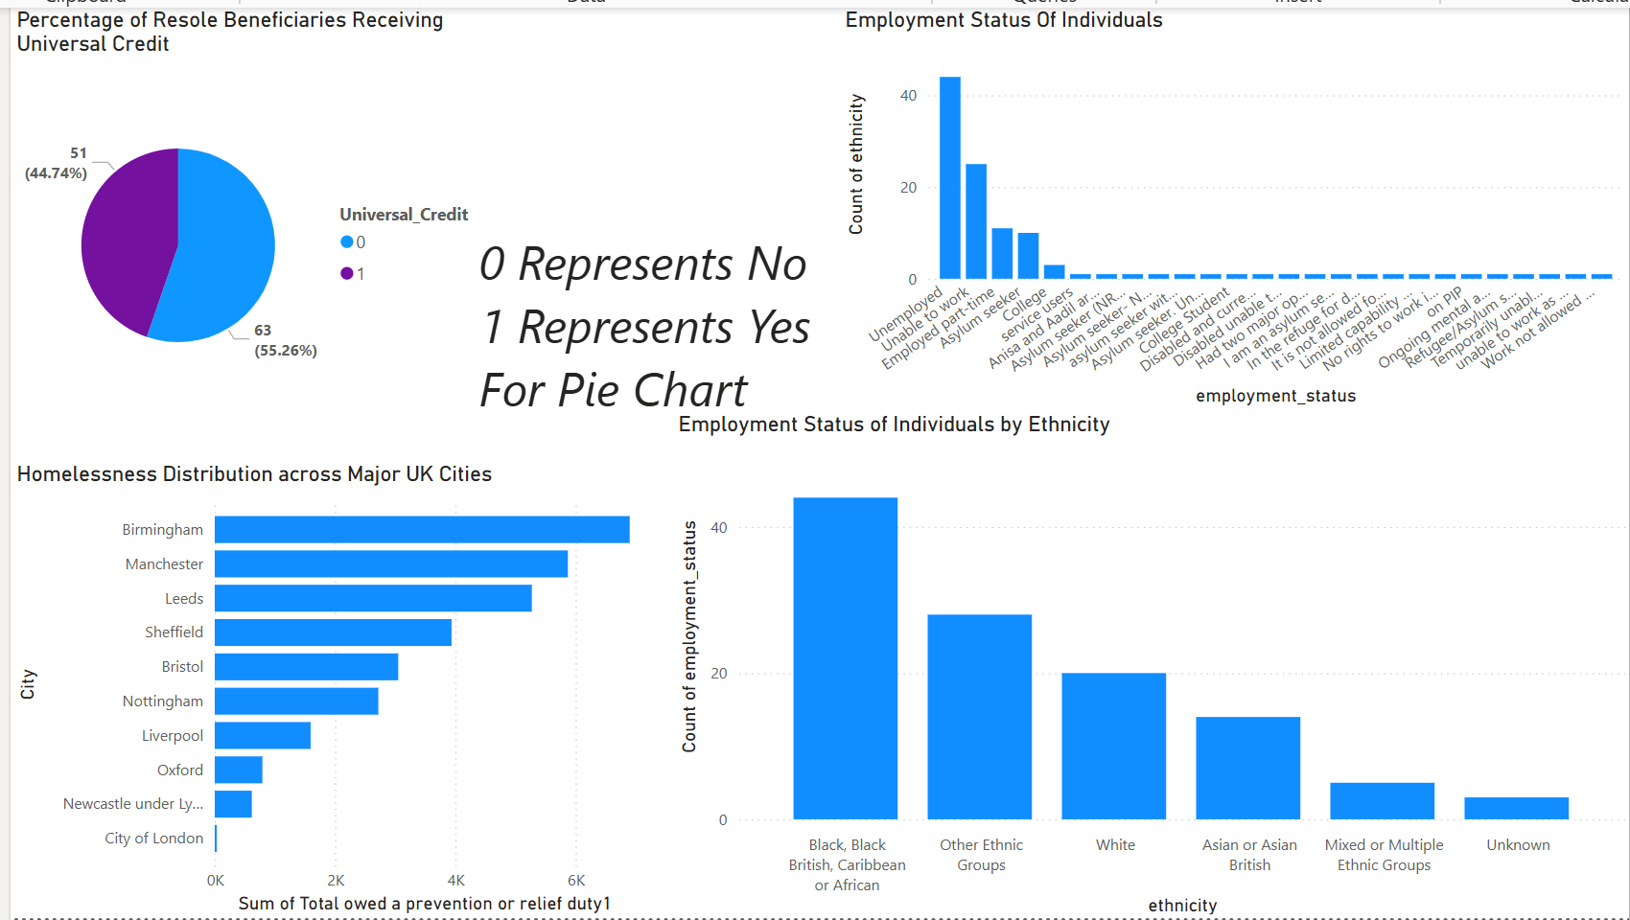

**19th March – Finalising WBS, Gantt Chart, & Dashboard**

I completed the WBS time plan because WBS consists of two tables, one for assigning tasks clearly and the second is the time plan for each task to be completed. Additionally, I completed the Gantt chart, by implementing necessary changes based on feedback. Also, the dashboard was completed, and I made sure to update the meeting minutes.

**Next Steps:**

Getting feedback from the team on dashboard and plan to make improvements if changes needed.

**20th March – GitHub Upload**

I was facing problem on how to upload my work on GitHub, but thanks to Kelvin for creating a video explaining in step-by-step detail on how to upload your work on GitHub. By Kel’s help through the video, I uploaded my work in GitHub.

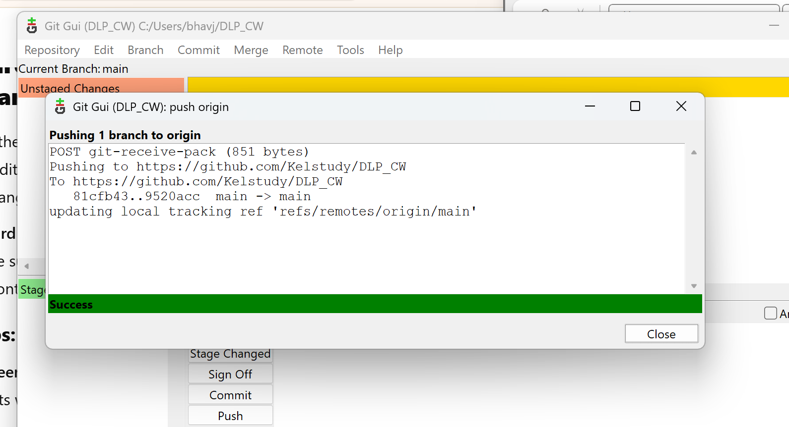

**23rd March – Presentation Preparation**

I contributed with Rawad to create the presentation, adding screenshots to support the findings.

**24th March – Adjustments**

Making slight changes to the report, added GitHub and Google Drive link.

**Reflection**

This project helped me improve my skills in Power BI, project management, and teamwork. It also allowed me in creating meaningful visualisation which was challenging at first but constantly getting feedback helped me refine my approach. Time management was a major problem, especially handling multiple tasks in a group, but through the use of Gantt chart, cleaning data, building dashboard and allocating the tasks to each member of the group.

Another challenge I found was using GitHub, but it was solved by the video that Kel created and I learned how to easily use GitHub which can be beneficial for the future.

Coordinating with the team and integrating feedback also required effort, but using GitHub for version control helped solved the issues. Overall, the project has been very fun and enjoyable. Also, it has helped me develop key skills such as communication, adaptability, organisational skills.

For future consideration, I should learn what goes into milestones and what to put in the reports.